Description
This project solves the problem of classifying brain MRI images into tumor categories using a convolutional neural network. The model learns visual patterns from MRI scans and predicts whether the image belongs to glioma, meningioma, pituitary tumor, or no tumor.

Tools and Libraries
Tool or Library | Used For | Code Explanation
Python | Main programming language | Controls the complete machine learning workflow.
PyTorch torch | Tensor operations and model execution | Handles tensors, moves data to  CPU or GPU, and runs the neural network.
torch.nn | CNN model building | Creates convolution layers, activation layers, pooling layers, dropout, flattening, and linear layers.
torch.optim Adam | Model optimization | Updates model weights using the Adam optimizer with learning rate 0.0001.
torchvision.datasets ImageFolder | Dataset loading | Reads Training and Testing folders where subfolders represent class labels.
torchvision.transforms | Image preprocessing | Resizes MRI images to 128 by  128, converts them to tensors, and normalizes pixel values.
DataLoader | Batch processing | Loads images in batches of 32 and shuffles the training data.
Matplotlib | Visualization | Displays sample MRI images and is used here to show the training loss curve.

Key Features
- Loads brain MRI images from Training and Testing folders using PyTorch ImageFolder.
- Preprocesses every image by resizing to 128 x 128, converting to tensor format, and normalizing RGB channels.
- Builds a three-block convolutional neural network with Conv2D, ReLU, MaxPool2D, Flatten, Linear, and Dropout layers.
- Trains the CNN for 25 epochs using CrossEntropyLoss and Adam optimizer.
- Evaluates the model on the test set and calculates test loss and test accuracy.
- Includes a sample prediction cell, which predicts the type of brain tumor.
Code Part Explanation:

1. Data Loading and Preprocessing
The first code cell imports PyTorch, selects CPU or GPU, defines image transformations, and creates train and test DataLoaders. Images are resized to 128 x 128 and normalized before training.
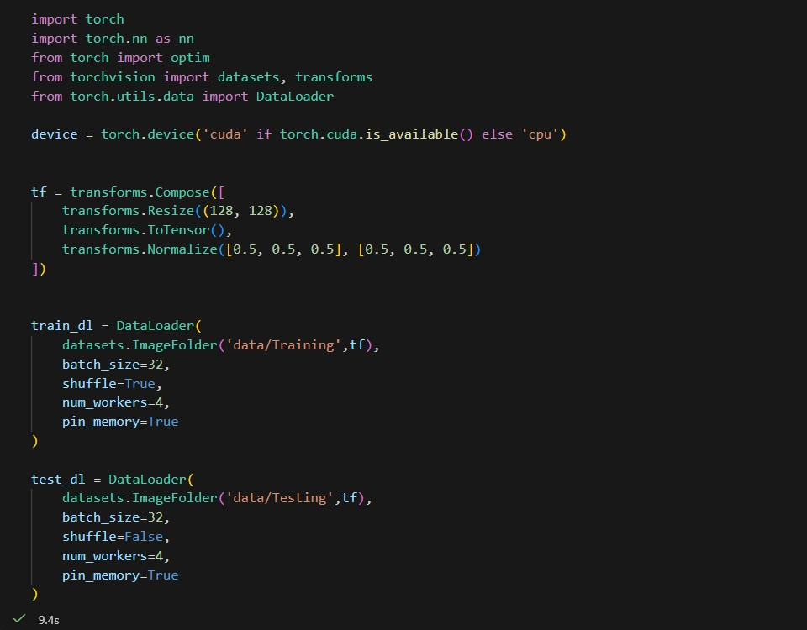

2. CNN Model Architecture
The model has three convolution blocks. Each block extracts image features using convolution, applies ReLU activation, and reduces image size using max pooling. The extracted features are flattened and passed through fully connected layers for four-class classification.
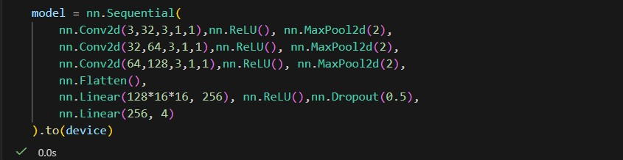

3. Training Loop
The training loop runs for 25 epochs. For every batch, the optimizer resets gradients, the model predicts outputs, loss is calculated, backpropagation is performed, and the optimizer updates model weights.

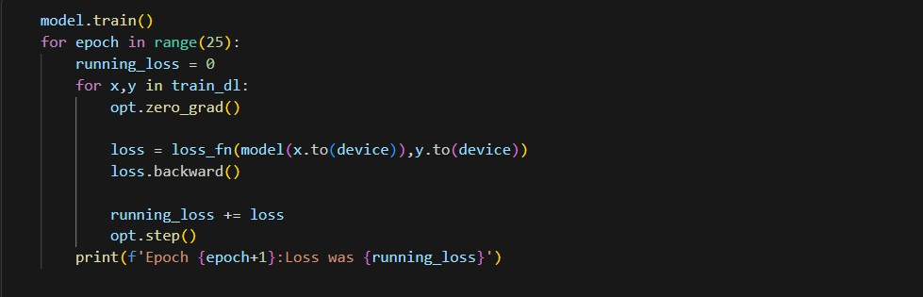

4. Evaluation Code
The evaluation code turns off gradient calculation, predicts labels for test images, calculates average test loss, counts correct predictions, and prints final accuracy.

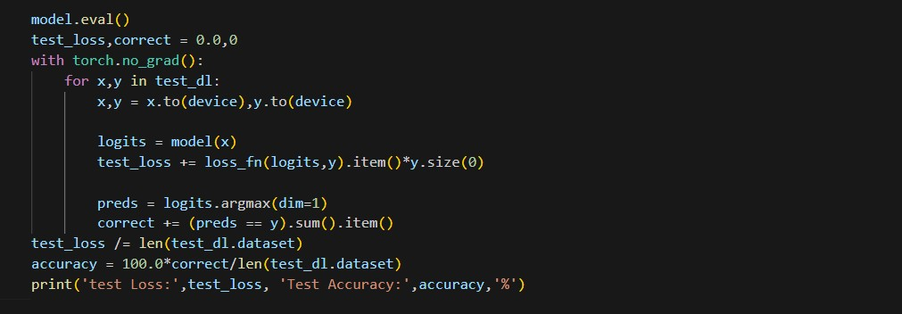
Output:
Final evaluation result: Test Loss = 1.33098, Test Accuracy = 89.9375 percent.
Metric | Value
Training epochs | 25
Final training loss | 8.316158294677734
Test loss | 1.3309822135214926
Test accuracy | 89.9375 percent
Sample prediction class | Glioma
Sample true class | Glioma

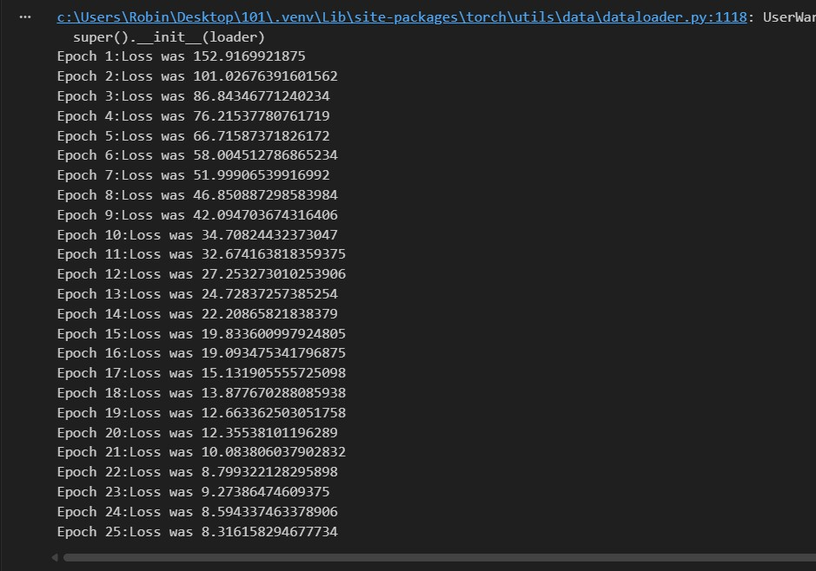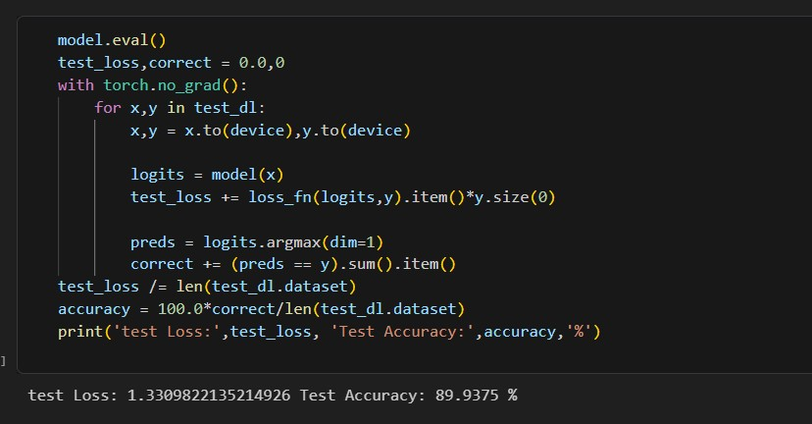

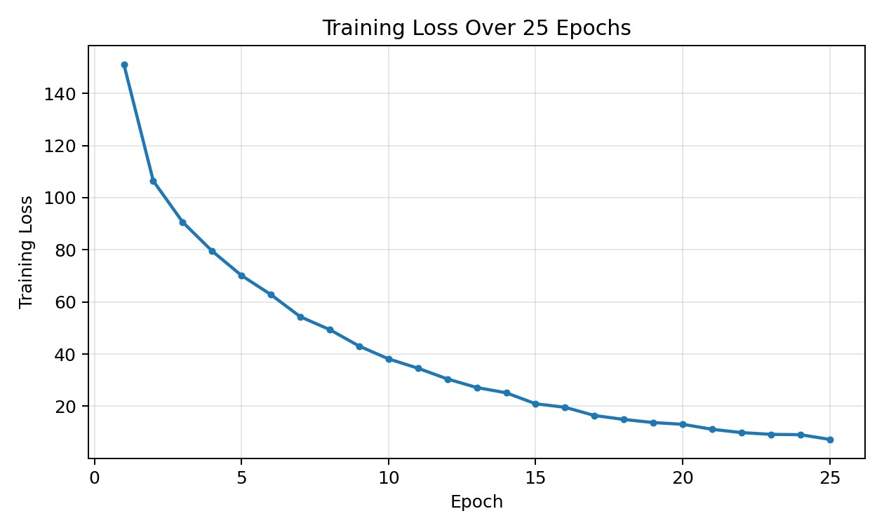
Training loss decreased from 152.9169 in epoch 1 to 8.3161 in epoch 25, which shows that the model learned useful image patterns during training.
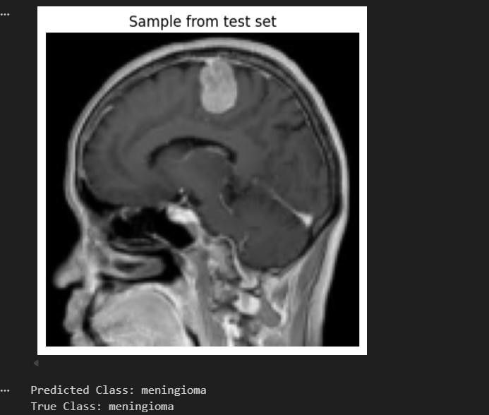

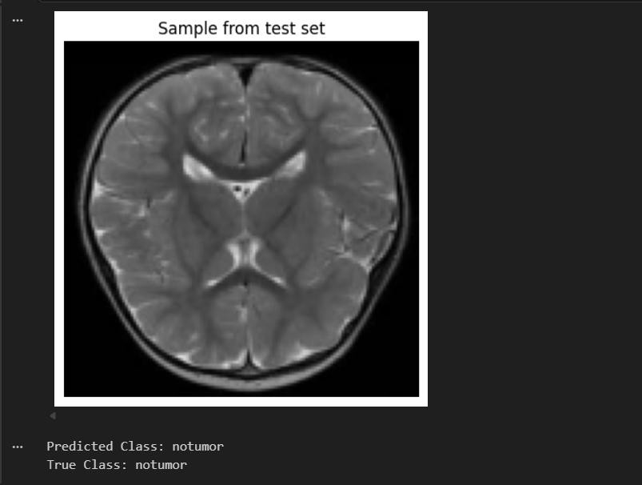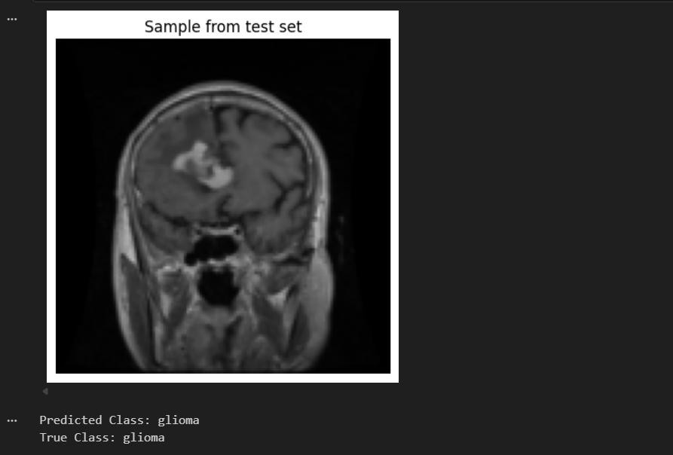

Challenges and Limitations
During this project, one of the main challenges was working with MRI image data because the images needed to be resized, normalized, and properly organized before training the model. Since the dataset contains different brain tumor categories, the model had to learn visual patterns from medical images, which can be difficult when the differences between classes are small. Another limitation is that the model was trained only on the available Kaggle dataset, so its performance may not be the same on real hospital MRI scans or completely new datasets. The model also depends on the quality and balance of the training images. If some classes have fewer or less clear images, the prediction accuracy may be affected. The CNN model achieved good accuracy, but it is still a basic deep learning model. It may make incorrect predictions in complex cases. Also, the model does not explain why it predicts a specific tumor class, so it should not be used as a final medical decision system. It can only be used as a support tool for learning and research purposes.

Conclusion
This project successfully developed a convolutional neural network model to classify brain MRI images into different tumor categories. The model was trained using Python and PyTorch, and the final evaluation showed that it could classify test images with good accuracy. The project demonstrates how deep learning can be applied to medical image classification tasks.The system can be improved in the future by using a larger and more diverse dataset, applying data augmentation, tuning hyperparameters, and using advanced pre-trained models such as ResNet, VGG, or EfficientNet. More evaluation methods, such as a confusion matrix and precision, recall, and F1-score, can also be added to better understand the model performance.

